[https://ashidaelectronics.com/wp-content/uploads/2014/11/Ashida-Electronics-logo.png](https://ashidaelectronics.com/)

**Company Profile**

INTEGRATED SOLUTIONS: PROTECTION & AUTOMATION

**ASHIDA ELECTRONICS**, a partnership firm was established in 1970 as manufacturers of geo-engineering and water management instruments. In 1985, the company started manufacturing Power System Protection Relays. Eventually the company was converted into a Private Limited Company in the year 1994.

ASHIDA is a leading Indian manufacturer & supplier of complete range of Numerical, Static & Auxiliary Protection Relays. ASHIDA is the first company in India to develop a range of Static and Numerical Relays indigenously.

In addition to Protection Relays, ASHIDA manufactures Control & Relay Panels and have its own SCADA System with all latest communication protocols like IEC 61850, IEC 60870-5- 103,DNP 3, MODBUS etc.

All Relays are thoroughly Type-Tested for their vital technical parameters & also for EMI/EMC as per International IEC - Test Specifications. Numerical Relays are type tested for their vital parameters from **KEMA and ASTA.** More than 1 million Relays are protecting key electrical installations all over the world.

As per the specific requirements & the needs of the client ASHIDA can Design, Manufacture,Supply, Install & Commission entire ASHIDA SCADA System.

ASHIDA has successfully completed around 300 projects at various voltage levels from 11KV to 400KV in India & Abroad.

ASHIDA has received **Best Product Developed** award in world’s largest exhibition ELECRAMA 2016 organized by IEEMA.

**ASHIDA ELECTRONICS PVT LTD**, has obtained ISO 9001:2015 Certificate from NABCB & UKAS.ISO 9001 covers all the activities right from Marketing, Designing, Production and Servicing.

[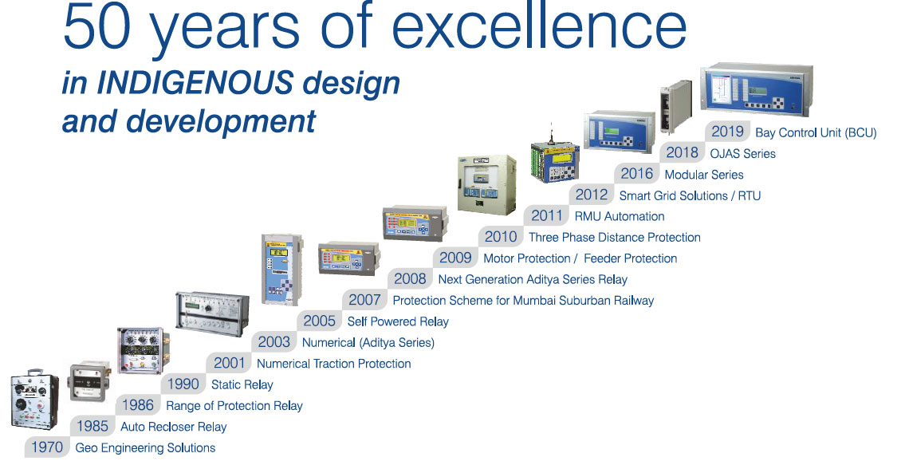](https://ashidaelectronics.com/wp-content/uploads/2020/03/50years-1970-2019.jpg)

Our Major Products:

Numerical Protection Relays :

* Numerical Relays has large number of protection functions. The unique programmability allows the user to form its own logic suitable for existing site conditions. This saves a lot of wiring and panel space and becomes very cost effective. The relay is having open communication protocol, which allows monitoring the substation remotely.
* ASHIDA has designed economical & reliable Multifunction Draw-out/Non draw-out **Feeder Protection Relay ADR245B/ADR241A/ADR241B/A21F** provides integrated Protection, Control and Monitoring functions for Sub Transmission Lines, Underground cables and Distributed Feeders.Protection & Control System.
* Relay designed with fast and selective tripping ensures the stability and availability of electrical power system.
* **Transformer Differential Protection Relay ADR233B/A21T** provides integrated Protection, Control and Monitoring functions for Transformers.
* **Motor Protection Relay ADR244A/ADR244B/A21M** provides integrated Protection, Control and Monitoring functions for Induction motors.
* **Generator Protection Relay ADR245G** provides protection, control & monitoring of distributed generator to achieve sensitivity and selectivity on phase and ground faults.
* Normally all electronics units require some sort of auxiliary power supply for its own operation. Self Power RMU Protection Relay ADR241S is a special protection relay which can take power supply from the current it is monitoring. This unique feature makes ADR241S relay well suitable for RMU (Ring Main Unit).
* ASHIDA is one of the major Suppliers of protection system for 25kV railway traction system. ASHIDA has developed complete protection scheme for Indian Railways.

SCADA :

* SCADA system is a very important tool to monitor power system effectively. ASHIDA has developed very versatile SCADA system software which can communicate with variety of Relays / RTU having different protocols such as IEC 60870-5-103, DNP 3, MODBUS, IEC 61850 etc.
* Energy Management Software are very crucial to co-gen plants, industries etc to analyse the import/export energy etc. These reliable software from ASHIDA are a part of the ASCADA suite.
* Proven SCADA systems with in-house development of hardware (RTU) as well as the SCADA software.
* ASHIDA has Designed, Developed & Perfected SCADA (Supervisory Control & Data Acquisition System) System especially for Substation Automation for Electrical Utility application.
* The concepts we have used in our ASHIDA SCADA system employs Remote Terminal Units (RTUs), Station Controller, Intelligent Electronic Devices (FCCM) etc. A-SCADA can integrate different makes of Bay Controller Units (BCUs), Numerical Protection Relays and Multi Function Meters with integration of multiple protocols.
* ASHIDA SCADA system covers complete Energy Management System, Alarms & Status monitoring, recording & controlling outputs. It measures Digital Inputs (DI), Analog Inputs (AI) & Digital Outputs (DO) and executes complete protection Relay analysis.

Control & Relay Panels :

* ASHIDA Numerical Protection & Auxiliary Relays offer a perfect solution for integration into Substation Automation System. ASHIDA manufactures Control & Relay Panels for protection of Feeders & Transformers at 11kV to 220kV voltage levels. ASHIDA also gives solution for Line Differential Protection, Bus Bar & Bus Coupler Protection, Integrated Motor Control Systems etc.

https://ashidaelectronics.com/wp-content/uploads/2013/02/footerlogo.pnghttps://ashidaelectronics.com/wp-content/uploads/2013/02/ashida_new.png

**Ashida Electronics Pvt. Ltd.**  
Ashida House, Plot No. A-308, Road No. – 21,  
Wagle Industrial Estate, Thane – 400604, India.  
Tel :      022 – 61299124 / 25  
Fax :     +91 – 22 – 25804262  
Email :   [sales@ashidaelectronics.com](mailto:sales@ashidaelectronics.com)  
Web :    [www.ashidaelectronics.com](https://ashidaelectronics.com/)**Ashida.SwiconsHome**